Who runs Green Gang?
The Green Gang started 6 years ago working with GANG (Gillingham Action For Nature Group) on nature reserves, the Town Meadow and public open space around Gillingham. Green Gang makes its own rules.
Bob Messer, chair of GANG, is the Co-ordinator of Green Gang. He has attended a number of one day courses on Recovery, Anxiety, Depression and Understanding Unusual Experiences to add to seven years experience of working with volunteers recovering their mental health on Gang projects.
GANG is insured, the coordinator has DRB clearance and a First Aid certificate. Other GANG committee members join the Green GANG as required.
For further information or request to join Green Gang contact Bob Messer, Co-ordinator Green Gang
Email: bobmesser@hotmail.com
Phone: 07529225295

Green
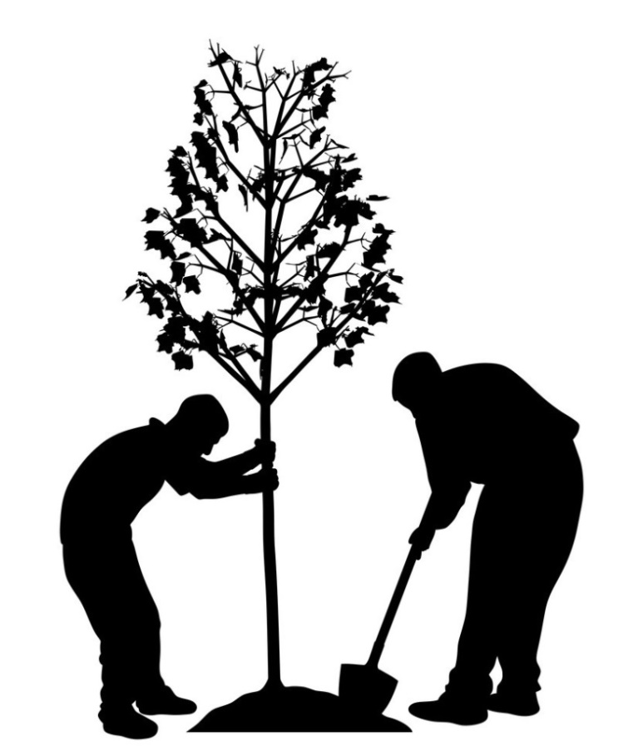
A group working together regaining their mental health while improving the environment.

What does the Green Gang do?
We are a group of adults recovering our mental health. We work together for the environment. We have built a footpath, installed a bench, planted trees, cleared footpaths and rubbed down and painted benches.
In the Winter we make things in a workshop, out of the cold and rain.
We meet once a fortnight for about three hours with breaks for refreshments.
Our numbers are small and we have a strong tradition of mutual respect and support. There are jobs to suit everyone.
There is a short safety talk before each session.
What do I need?
We wear appropriate clothes – long sleeved shirt, hat, long trousers or shorts and stout shoes or boots.
We bring a bottle of water and a small snack.
GANG provides gloves, high- viz jackets and all tools.

How do you join?
Contact the co-ordinator to arrange to meet with him to find out more including details of the next session.

For the first two sessions you must come with a relative, friend or health professional. The group and the new member then decide if they are happy working together.

There is a brief health questionnaire to fill in on physical health conditions, allergies and contact phone numbers.

There is no charge or membership fee.

