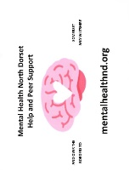
Mental Health North Dorset Help and Peer Support
WINTER EVENTS
NOVEMBER
10th Peer Support Group, RBL Club, Gillingham
14th Peer Support Group, Stour Connect, Stur. Newton
17th Peer Support Group, The King’s Arms, Shaftesbury
19th Coffee Morning 10.30 am – 12 noon
Methodist Hall, Gillingham. Refreshments, Raffle, books, puzzles, hand made items for sale
24th Peer Support Group, RBL Club, Gillingham
30th At Socially Connecting Shaftesbury, Town Hall.
December
1st Peer Support Group, RBL Hall, Shaftesbury
8TH Peer Support Group, RBL Club, Gillingham
12th Peer Support Group, Stour Connect, Stur. Newton
15th Peer Support Group, RBL Hall, Shaftesbury
22nd Christmas Party, RBL Club, Gillingham

See website mentalhealthnd.org or
Contact Amanda on mentalhealthshaft2520@gmail.com or 07749 062 327 for more details

