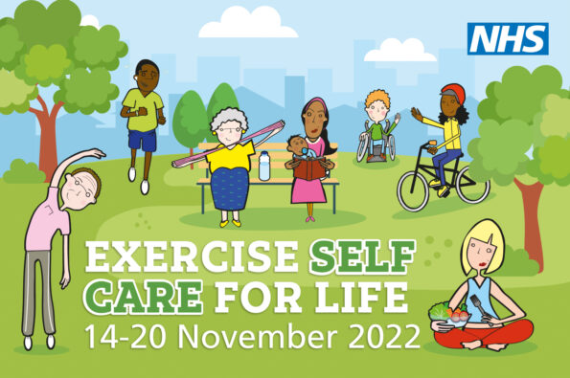

Self Care Week is a UK-wide annual awareness week that focuses on what we can all do to keep ourselves as healthy as possible. This includes living well with a health condition. Visit the Self Care Week website for lots of ideas, inspiration and stories of how people can find the best way to self care: www.selfcareforum.org/events/self-care-week

Here at Blackmore Vale Partnership we are marking Self Care Week by promoting the Five Ways To Wellbeing:
Connect - with others

Be Active - physically and mentally

Keep Learning - new things and about yourself

Take Notice – slow down and be present

Give – time to others

Our Wellbeing Team are sharing lots of information and ideas that support these Five Ways To Wellbeing – look out for social media posts and the Blackmore Vale Partnership website. We are also holding two morning drop-in sessions for anyone to call into the Surgery for more information and a chat about Self Care can help you live well. These are 10am-12pm on:

Weds 16th Nov (Abbey View Surgery) Thurs 17th Nov (Sturminster Medical Centre)

