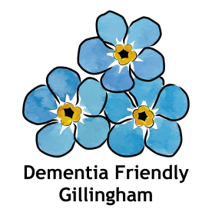

We invite you to come along and join us for a very relaxed
Dementia Awareness Session
In
St Mary’s Church, Gillingham
On
Tuesday November 1st
2.30pm – 3.30pm

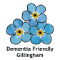

Helping a person with dementia to maintain quality of life is extremely important, and we can all play a part in doing that; we just need to know how.

Dementia awareness is so important whether you are affected yourself, or know someone that is, or do not know anyone at all who is.

Dementia impacts in so many ways, socially, physically, and psychologically, not only for the people who are living with dementia, but also for their loved ones, carers, and society in general, who all need our support.

The lack of awareness and understanding of dementia, often results in stigmas and barriers to diagnosis. Early diagnosis is key to getting the treatment and care which is now available.

This short session will help everyone to have the essential knowledge and understanding to support and enable people living with dementia, to live well with their dementia.

No need to book, just bring yourself along and encourage others to come.
For more details phone 01747 837908.

